Turkey Apricot GDP Values Time Series Analysis

Ipek Sarihan   
*Statistics Department*   
*Middle East Technical University* Ankara, Turkey  
ipek.sarihan@metu.edu.tr

*Abstract*—Apricot gross production value forecasts play an extremely crucial role in terms of economic planning, market dynamics, agricultural policy, export, and trade for Turkey. This analysis utilizes Turkey’s yearly Gross Production Value (GDP) data from 1961 to 2022 to construct a ten-year ahead forecast using the FAOSTAT data. The analysis process started based on foundational approaches including cross-validation, and statistical tests to understand the featuristic properties of data such as the Augmented Dickey-Fuller Test, anomaly detection, and Box-Cox transformation. The analysis identifies long-term trends, and clustered possible volatility structure in production values. After thorough diagnostic checks, we utilize statistical models including ETS, TBATS, NNETAR, and PROPHET to obtain enhanced prediction accuracy on the test set.

# Introduction

Apricot production has a significant place in Turkey’s agricultural sector. In 2023, Turkey was by far the leading exporter of dried apricots with an export value amounting to a total of over 395 million U.S. dollars worldwide. (Statista, 2024). Having this excessive potential leads us to be more precise and think more about our next steps. Apricot Gross Production Value is the representation of the total market value of apricots, and the changes that occur in GDP value has a direct effect on Turkey’s trade balance and domestic agriculture in terms of financing, labor force, and livelihood of the local region.

Given the economic importance of apricot production highlights the importance of actions in analyzing its gross production value over time. These analysis can be influenced by climatic, financial, and political factors in years. Therefore, this study aims to address these changes by conducting a time series analysis of FAOSTAT data to uncover trends, seasonal patterns, and future predictions in apricot gross production value in Turkey. In this idea, our main question that is ‘How has the gross production value of apricots in Turkey changed over time?’ will conserve its own remains during the whole project. In our apricot data, we have 62 observations from 1961 to 2022 and their gross production values in the current thousand SLC (thousand Standard Local Currency).

## Time Series Plot of Our Apricot Data

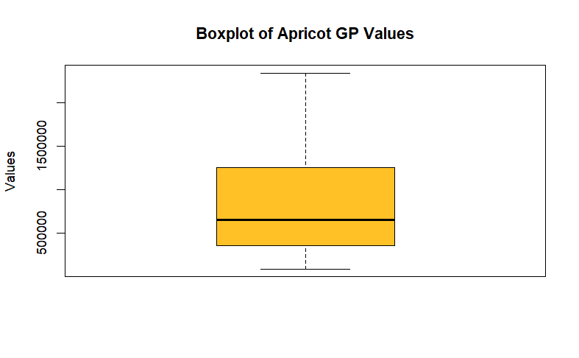In time series plot, we observe an overall increasing trend, and also there exists a pattern with some high rising and falling fluctuations over time which may interpreted as the potential existence of clustered volality. Therefore, since the mean of the series increase over time, and it performs non-constant variances in the later years (post-2000), this suggest us our series is not stationary. Furthermore, the plot shows neither seasonal patterns nor extraordinary behaviours that we can interpret as outlier. To be ensure about our visual graph comments, we checked the Augmented Dickey-Fuller Test, boxplot, peridiogram graph, and frequency of our series. Our frequency function resulted as value of 1 that also indicates we have yearly data, and our ADF test is resulted with a p-value as 0.31 that is higher than our general alpha value 0.05, and lead us to fail to reject our null hypothesis that is we have stationary data. Respectively our boxplot and peridiogram graphs are shared below:

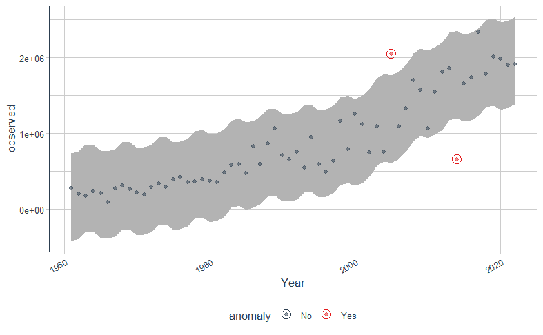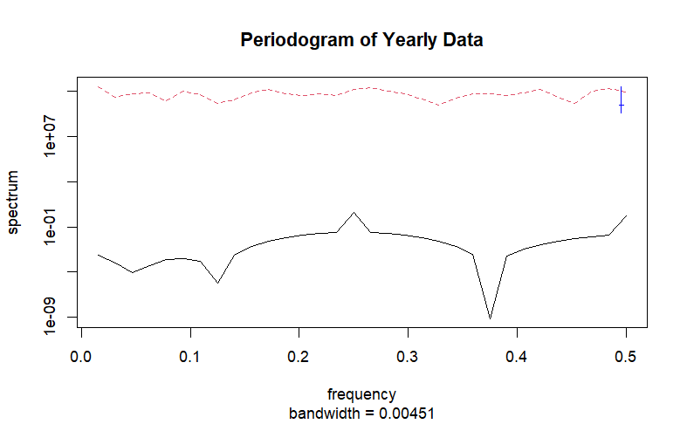There seems no outliers in this dataset, as there are no data points plotted outside the whiskers The distribution seems fairly symmetrical, as the median is roughly centered in the box.

In the provided plot, there is no clear or significant peak in the periodogram, therefore we can conclude that no dominant seasonal or periodic pattern is evident in this data, The time series likely does not have seasonality.

To sum up, we can conclude that we have non-stationary data with increasing trend, and we don't observe any seasonal or periodic pattern. If present, may be very weak or associated with longer-term cycles

## Cross-Validation

To prevent overfitting and ease the working with unseen data we split our data in 2 parts as apricot_test and apricot_train data. For the test data, we leave 4 of the 62 observation data, and the rest as train data.

## Anomaly Detection

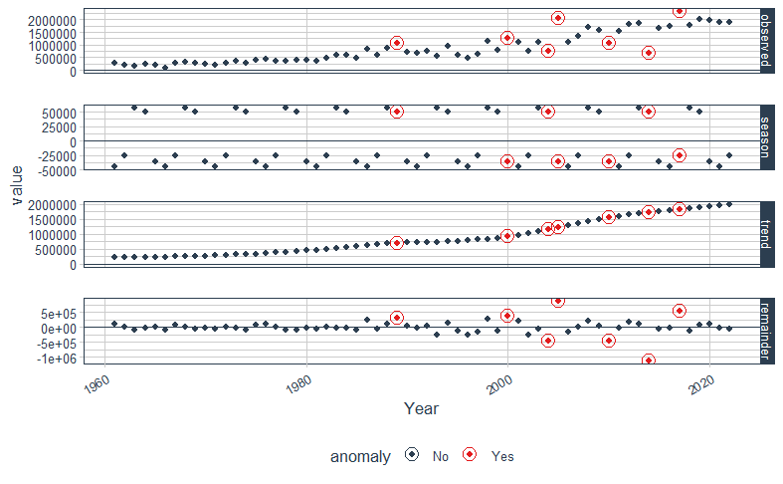Anomaly Detection was conducted using the tibletime, timetk, anomalize, stats package in R.

Since trend is a large factor we prefer 'stl' method to 'twitter' method as we don't have strong seasonality.

The observed anomalies that are representing as red points indicate that where the data deviates significantly from the expected patterns.

The anomalies occur around the years approximately 2005 and 2010, For the researches we can discover that between 1995 and 2010, Türkiye's agricultural sector experienced shifts, including changes in land use and production quantities. Also there is another research that conducted between 2006 and 2008 in Hatay, Turkey, demonstrated significant differences in fruit set percentages among various apricot cultivars, with some cultivars exhibiting as low as 2.3% fruit set. These events may have caused anomalies.

After implying cleaning anomalies, we conduct Shapiro Wilk’s test to check normality, and density graph of our data to comment on skewness to decide on whether our series require transformation or not.

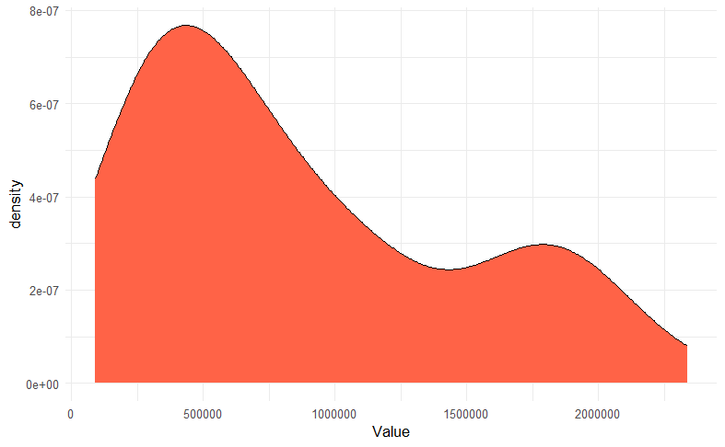According to Shapiro Wilk’s test’s p value has a very small value than alpha value as 0.05, we reject the Null Hypothesis. Our data is not normally distributed and it is skewed, therefore we need to conduct Box-Cox transformation.

## Box-Cox Transformation

* Since our lambda value concluded as 0.177 is not so close to 1, therefore transformation might improve the normality or linearity of the data. The plot of transformed and trained data is supplied below.
* After Box-Cox variances become better. Data obtains a behavior more close to stationary.
* Conducting Shapiro Wilk’s test to see whether transformation helps us to deal with non-normality.
* Test resulted with a p-value as 0.06763 which is higher than our sigma value 0.05
* After Box-Cox transformation our series become normal.

## ACF, PACF Analysis and Stationarity Testing

There exists slow linear decay in ACF, our process is not stationary which necessitating us differencing. To be fully ensure, we conduct several tests to achieve stationary.

Conducted Test & Interpretation of Their Outputs

* KPSS Test for Level Stationarity

p-val is 0.01 for alpha value 0.05, reject H0, so the process is not stationary

* KPSS Test for Trend Stationarity

p-val is 0.1 for alpha value 0.05, fail to reject H0 that has stochastic trend

* Augmented Dickey-Fuller Test

p-val is 0.021 for alpha value 0.05, we reject H0 that is process is not stationary

,therefore based on the results of these three tests, it can be concluded that the series is non-stationary, and applying differencing may effectively address this issue.

In our series, we only have one regular unit root. After implementation of differencing, all our new test results state that the series is stationary and stochastic trend.

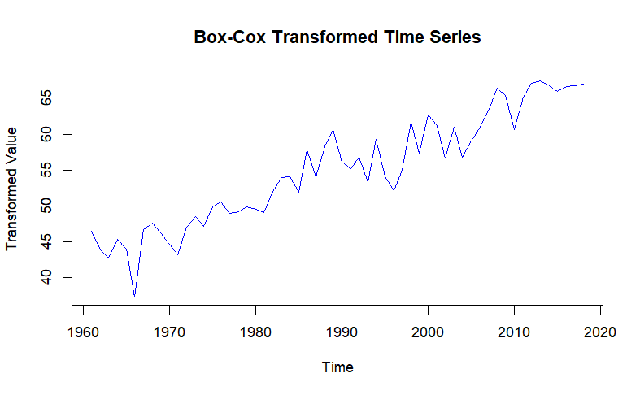

## metin, diyagram, ekran görüntüsü, çizgi içeren bir resim Açıklama otomatik olarak oluşturulduACF and PACF Plots After Differencing

metin, yazı tipi, ekran görüntüsü, beyaz içeren bir resim

Açıklama otomatik olarak oluşturuldu

Since our series achieves stationarity, we can obtain models for our estimations.

## Identifyiıng Proper Models

Based on the ACF and PACF plots, the suggested models are as follows:

* ARIMA (2,1,0): ACF model shows slight exponential decay that can lead us to think AR (2) model
* ARIMA (2,1,1): Since there exists a slight not clear exponential decay in ACF, we can still consider the significant spike at lag 1 in ACF plot
* ARIMA (1,1,1): We’ve observed another significant spike at lag1 in PACF plot, so it would be better for checking, also it is suggested from ESACF plot
* ARIMA (1,1,0)

We observed any seasonal pattern, so we utilize ARIMA models.

In the ACF plot, there seems lag7 is on the border and potential candidate for significant spike, however lag7 is higher valued lag that we would not prefer in our models, therefore we couldn’t consider it in our models.

Checking the significance of each model by comparing informational criteria to decide the best model, fitting ARIMA models

Interpretation:

* fit1 is significant with AIC: 1557
* fit2:
* AR2: not significant with AIC: 1559
* MA1: is not significant
* fit3:
* AR1: not significant with AIC:1557
* 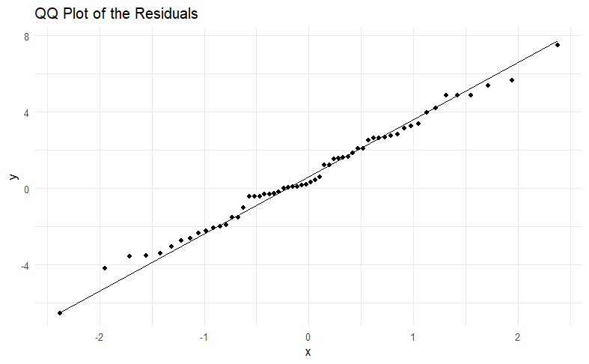MA1: significant
* fit4:
* AR1: significant with AIC:1559

We can choose Model1 as the best model that is ARIMA (2,1,0) with significance and smallest AIC value,

metin, yazı tipi, çizgi, ekran görüntüsü içeren bir resim

Açıklama otomatik olarak oluşturulduComparison Table:

## Diagnostic Checking

Checking residuals diagnostic plots

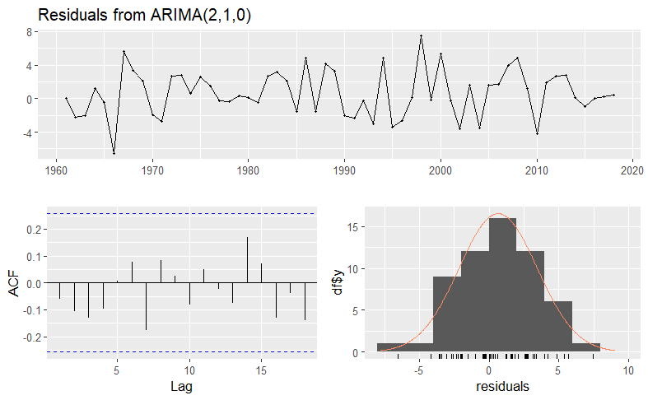

The residuals appear to fluctuate around zero, which is a good sign

The spread of the residuals seems relatively consistent over time, indicating that the residuals are likely to have a constant variance

The residuals appear to fluctuate randomly without any obvious patterns or trends.

No significant spikes that are out of the WN borders, no autocorrelation in residuals.

However, to confirm the adequacy of the model, we require more diagnostic checks

Test for Normality

To check normality assumptions, we conducted Shapiro Wilk’s test, and concluded with a p-value is higher than alpha value as 0.05, we failed to reject the Null Hypothesis. Our residuals are normal. The other test that used to check normality was Jarque Bera test that concluded that the obtained p-value (0.95) is higher than the significance level of 0.05.

Reject the null hypothesis. This indicates that the residuals of model do follow a normal distribution.

We also utilized QQ-plot to gain a deeper understanding of normality which also shows the tendency to follow the normal.

With these tests and QQ-plot we can accept the normality of errors.

Tests for Autocorrelation

To check for the if there are autocorrelation between variables or not, we conducted a Box-Ljung test, Breusch-Godfrey test for serial correlation,

* Box-Ljung Test

The p-value 0.55 is greater than significance level as 0.05

This means we fail to reject, the residuals show no significant autocorrelation

* Breusch-Godfrey Test

The p-value 0.79 is higher than the significance level 0.05

This means we fail to reject H0

There is no significant evidence of autocorrelation in the residuals.

Based on the inferences drawn from these two tests, there is no correlation among the residuals.

Tests for Heteroscadasticity

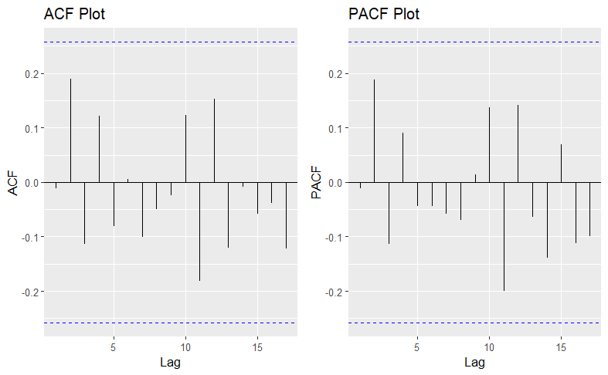ACF and PACF Plot of Rsquared Residuals

There seems no significant spike, all lags are in WN bands. However one of the lag is very close to the boundries, lets check it via formal tests:

* Studentized Breusch-Pagan test

The p-value as 0.9 is much larger than 0.05 meaning we fail to reject the null hypothesis.

This suggests that there is no evidence of heteroscedasticity

* ARCH LM-test

The results of this test also suggest that there is no heteroscedasticity problem.

So, we conclude that homoscedasticity assumption is also satisfied.

At the end of diagnostic checks, we can make conclusions on;

We satisfied assumptions of no correlation and no heteroscedasticity problem,we could satisfied the assumption of normality based on Shapiro Wilk's test and Jargue Bera Test.

## Forecast

ARIMA Forecast

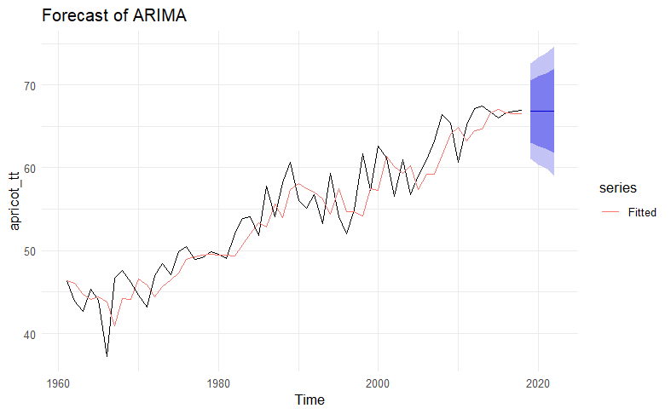

The forecast shows a continuation of the upward trend in the series, which aligns well with the se.

However, PI seems wide, then we need to check the performance of the model, but it is our forecast..

metin, ekran görüntüsü, diyagram, öykü gelişim çizgisi; kumpas; grafiğini çıkarma içeren bir resim

Açıklama otomatik olarak oluşturulduSince we have implied transformation, we need to conduct back transformation vith inverse BoxCox transformation.

ETS MODEL FORECAST

ETS model has alpha value with 0.198 which represents a slowly updated and errors related to past, and beta=0.019. We have multiplicative error, Additive trend, and None seasonality.

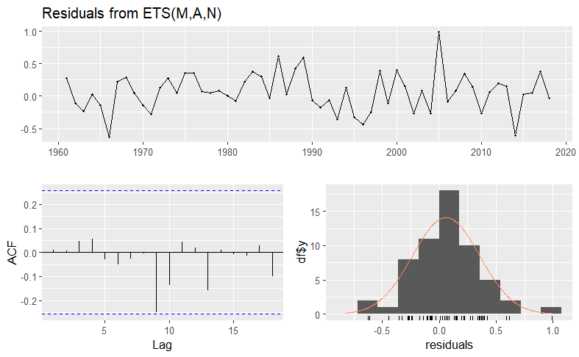Checking Assumptions of ETS Model

ETS model seems satisfying the all assumptions, but to have a deeper sight, we can examine each assumption individually

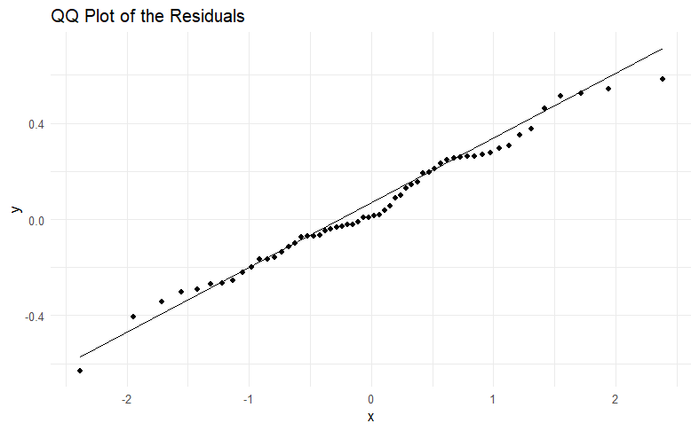Normality

The residuals seems normally distributed as they follow the straight line, However there is a minor slight deviations can be observable at the tails which might need further investigation.

Conducting Shapiro Wilk’s Normality Test to be sure about the normality. It resulted with a p-val as 0.75. ETS model residuals are normal.

Autocorrelation

Only in PACF plot one lag shows significance, but this is not serious problem for autocorrelation but to be sure we conduct Breusch-Godfrey test

Berush-Godfrey test resulted with a p-val as 0.752 which leads us to fail to reject our Null hypothesis. This suggests no significant autocorrelation in the residuals.

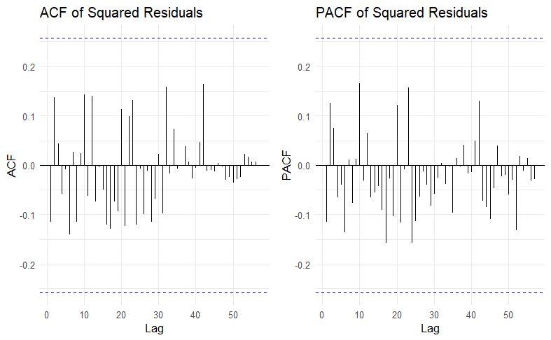Heteroscedasticity

We don't have any heteroscedasticity problem since we don’t have any significant spike out of the borders.

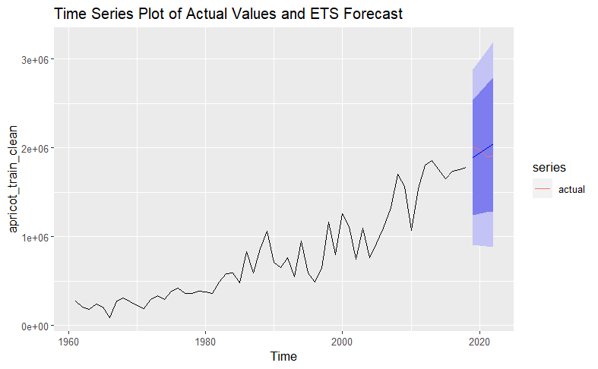ETS model satisfied all the assumption so we can obtain forecast values. Our forecast is:

Our forecast moves to the opposite direction with our actual value, however we can say that ETS model performs better than ARIMA model in terms of having smaller criteria from nearly all..

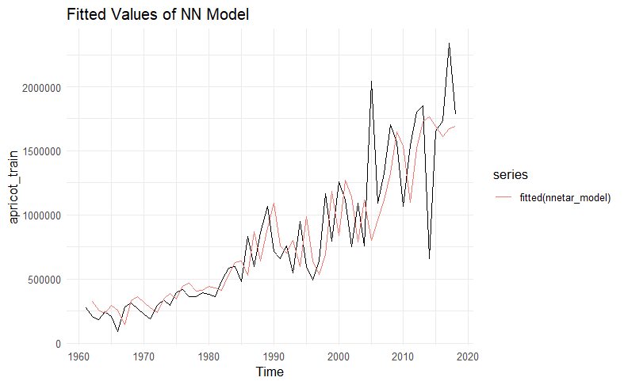NEURAL NETWORK MODEL FORECAST

The model is NNAR(1,1) model we have 1 lagged input variable and 1 neuron in the hidden layer.

Fitted values of a Neural Network Time Series (NNETAR) model (red line) follows back the actual data, it successfully captures the overall trend.

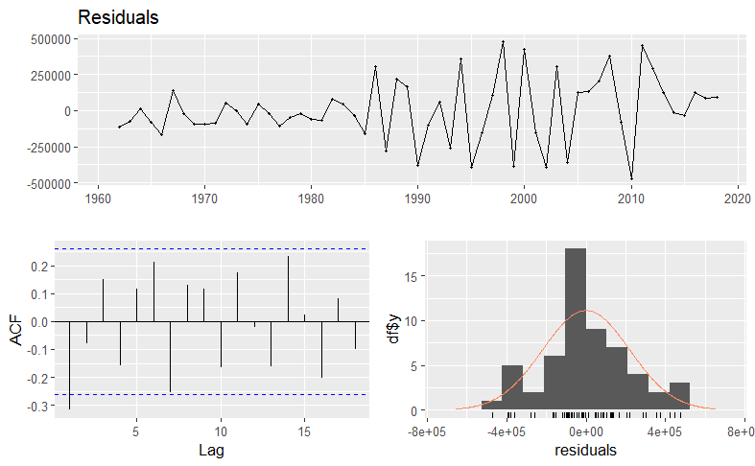Checking Assumptions of NNAR Model

Residuals seem normally distributed, and there is no exact pattern in time series. However density plot may put us in doubt of non-normality, since it show slight skewenes that we can check normality assumptions. Furthermore, in ACF plot one of the lags exceeds the WN border, this is not serious problem but It would be much better for checking the heteroscedasticity among residuals and autocorrelation assumption.

Normality

We conduct Shapiro Wilk’s Normality test to check the normality assumption of residuals that is concluded with normality of residuals with the p-val (0.26)

Autocorrelation

Utilized from Breusch-Godfrey test. After the test we concluded there is no serial correlation among residuals because of the test’s p-value as 0.33. We rejected Null hypothesis.

Heteroscedasticity

To check the assumption of heteroscedasticity, we conduct studentized Breusch-Pagan test. With p-value as 0.0008545, we reject the Null hypothesis. There is no heteroscedasticity problem.

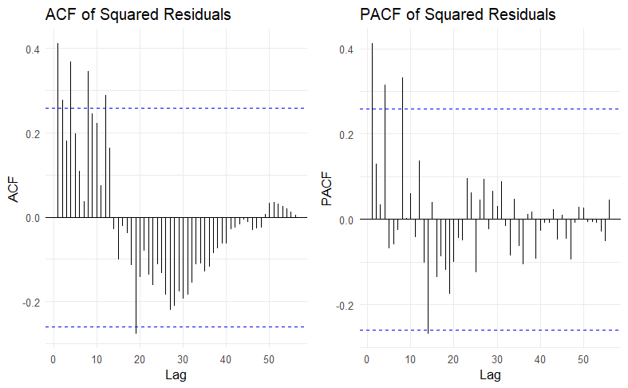Also checking the ACF and PACF plot's of rsquared values because rsquared refers to the periods to high or low variance appearing in clusters which may not be evident in the residuals themselves but can be seen in their squared values

Althoug the test result doesn’t show up with the heteroscedasticity, ACF and PACF plots reveals the homoscedasticity among residuals

Therefore, we can say that Neural Network model does not satisfy the assumptions. NNAR is not a preferrable model.

As it didn’t satifsy the assumptions, its forecast graph performs bad.

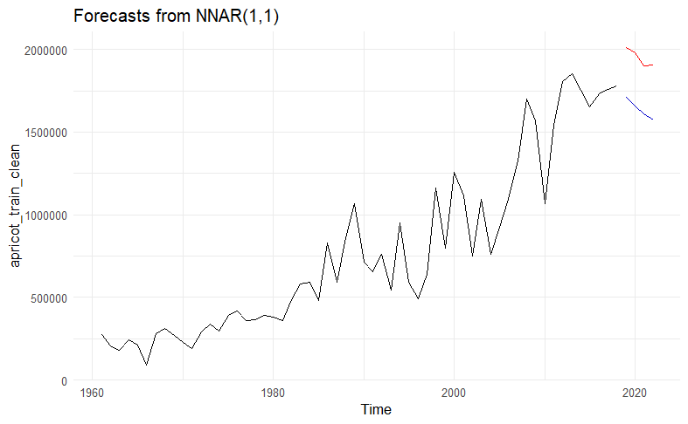

NNAR does not shows better performance from ETS and ARIMA model

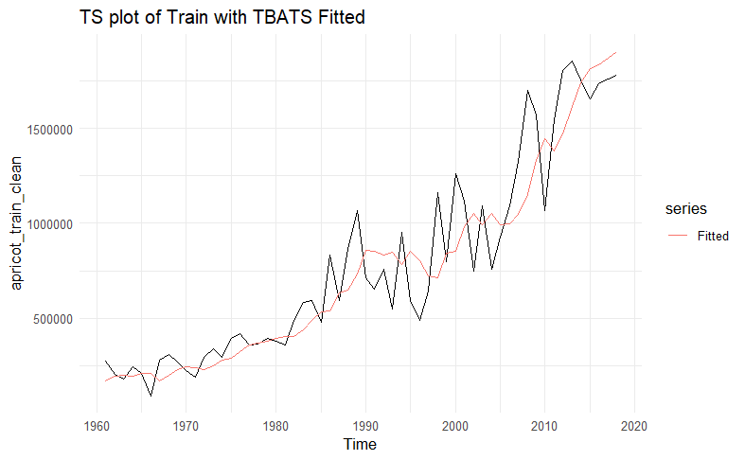TBATS MODEl

The model captures the general upward in data, there seems short term peaks.

Checking Assumptions

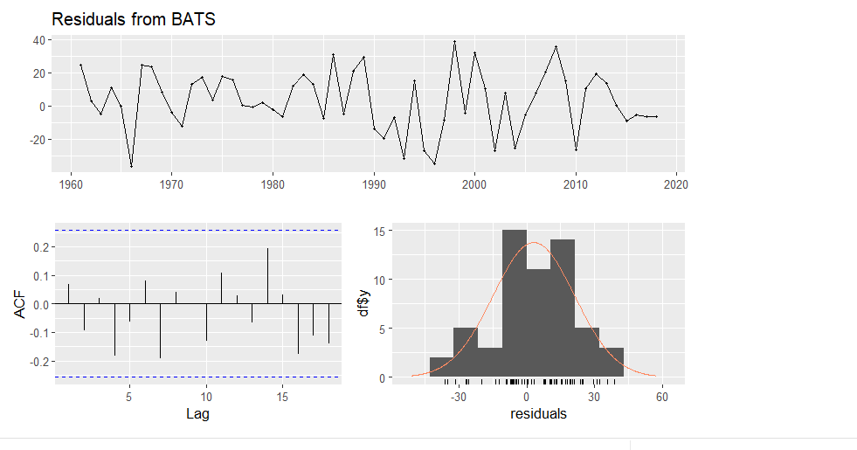

There seems no problem with the assumtions. However, since the density plot doesn’t have proper normal structure,it would be better to check the normality assumptions.

Normallity

QQ-plot

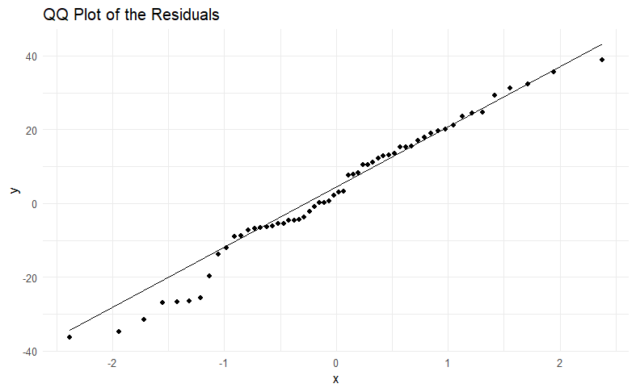

QQ-plot mostly preserve normally distributed residuals.

Conducting Shapiro Wilk’s Normality Test, Our residuals are normally distributed by the test with p-value as 0.348

TBATS satisfied all assumptions

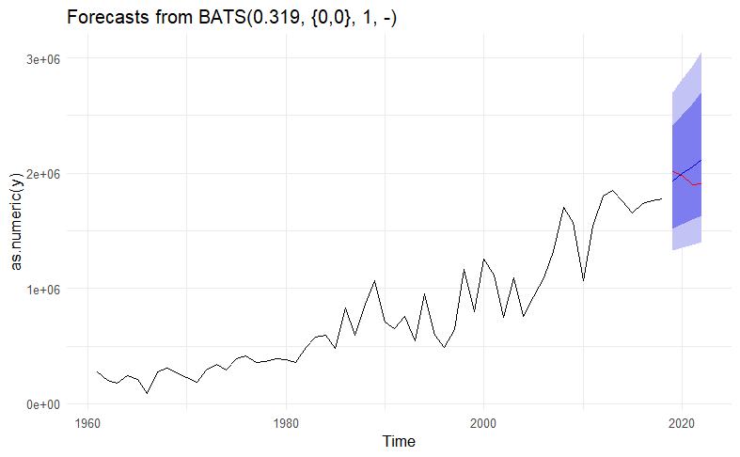Forecast from TBATS

PROPHET MODEL

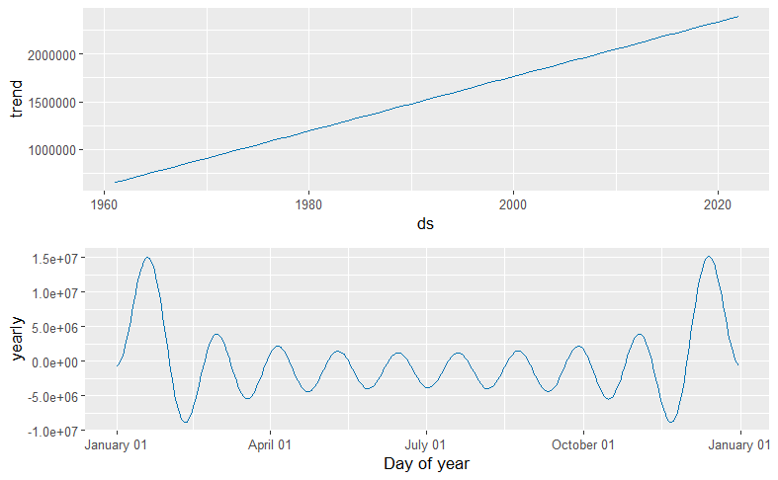We convert our ‘apricot’ data into prophet form data, and make a future dataframe for 4 periods

Checking Assumptions; not applicable to reach the assumptions of the prophet model.

metin, öykü gelişim çizgisi; kumpas; grafiğini çıkarma, çizgi, ekran görüntüsü içeren bir resim

Açıklama otomatik olarak oluşturulduForecast Plot

We can say that model captures the overall rising trend effectively.

To optimize and improve the model performence without overfitting, we use probabilistics methods in Hyperparameter tuning via defining best parameters

HYPERPARAMETER TUNING IN PROPHET

conclude that;

The smallest RMSE value was obtained when the parameters: * changepoint.prior.scale=0.5 * seasonality.prior.scale=0.5 * changepoint.range=0.6 We define our new prophet forecast based on these paramaters.

With tuning, our criterias in accuracy become more better.

Final MAPE Values of the Models

|  |  |
| --- | --- |
| MODELS | MAPE VALUES |
| ETS | 4.91857 |
| Neutral Network | 16.14273 |
| TBATS | 6.073693 |
| ARIMA | 9.392526 |
| PROPHET | 4.397383 |

|  |  |
| --- | --- |
| MODELS | ACF1 VALUES |
| ETS | 0.2965526 |
| Neutral Network | -0.6883229 |
| TBATS | 0.2942031 |
| ARIMA | 0.2685123 |
| PROPHET | 0.2786978 |

We conducted a comparison of all models based on accuracy metrics and assumption check. The results show that the TBATS model outperforms all other models, it performs the smallest values across all criteria except for the MAPE criterion. In MAPE criterion, the smallest forecast model is ETS. However, as I share there is not much severe difference between the values of ETS and TBATS, therefore TBATS can be still concluded as the best model.

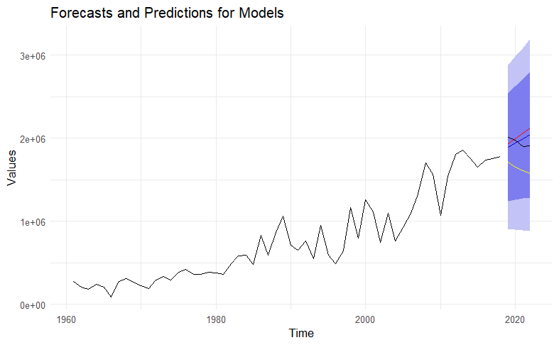Red line : TBATS

Black line: ARIMA

Yellow line: NNAR

Blue line: ETS

Our TBATS value follows the overall trend and goes through the line and above the other forecasts. TBATS is the best forecast model for us.

# Conclusion

In this time series analysis project, we try to provide key insights into the gross production value of apricots in Turkey. While determining our data and its features such as long-term increases, non-stationarity, and diagnostic checks we realized the outliers that occurred between 2005 and 2010 may be the results of the politically driven effects or natural effects on agriculture that happened in Turkey in those years. We found proper fits for our high statistical forecast models such as ETS, TBATS, NNAR, and PROPHET. Among these assumptions checking the models and the outputs from their accuracy criteria, we reached our best model as the TBATS model. Furthermore, interpreting the forecasts and predictions for model graphs, considering our primary question ‘How has the gross production value of apricots in Turkey changed over time? We reached the 4-year forecast of the gross production value of apricots in Turkey. After reaching the conclusion that it was performing an increasing behavior, we managed to complete our analysis.

.

## REFERENCES

1. *FAOSTAT*. (n.d.). https://www.fao.org/faostat/en/#data/QV
2. *Leading countries in apricot exports - Turkish goods*. (n.d.). Turkish Goods - From Turkey to the World. https://www.turkishgoods.com/post/blog/leading-countries-in-apricot-exports
3. Dried apricots (HS: 081310) Product Trade, Exporters and Importers | The Observatory of Economic Complexity. (n.d.). The Observatory of Economic Complexity. <https://oec.world/en/profile/hs/dried-apricots>
4. Statista. (2024, August 20). *Leading exporters of dried apricots worldwide 2023*. https://www.statista.com/statistics/1027377/global-leading-exporters-of-dried-apricots/